Day 10 Assignment Hypothesis Statements with Proof

1. Divorced Person having age in range of 22-60 are having NO ATTRITION and are happily commuting frequently to office ,whose distance from home is in range of 1-29Km.

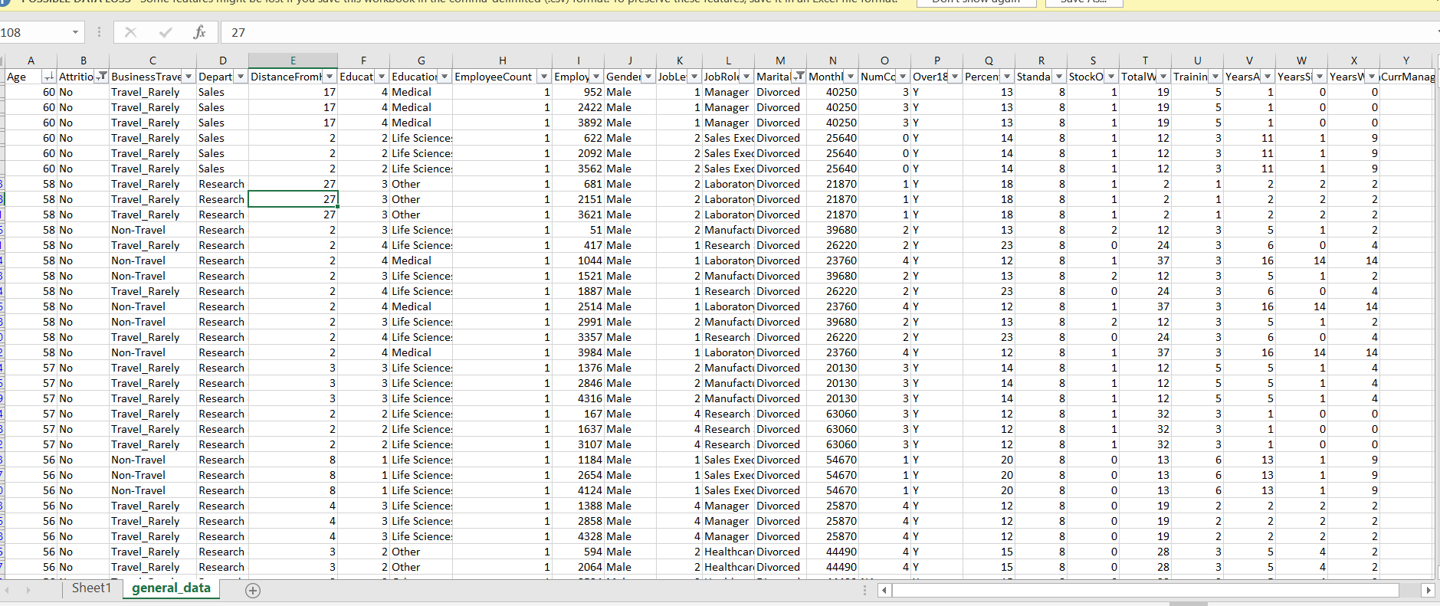

1. Females Employees are High on Attrition ,who are Divorced



3.Male Employees are having high Attrition then Females

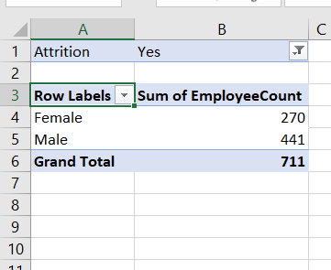

4.Singles are having HIGH Attrition Rate (possible reason be WORK LIFE Balance Missing)

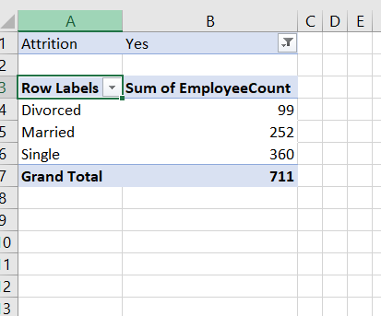

5.Attrition is HIGH for People from LIFE SCIENCE Education Background

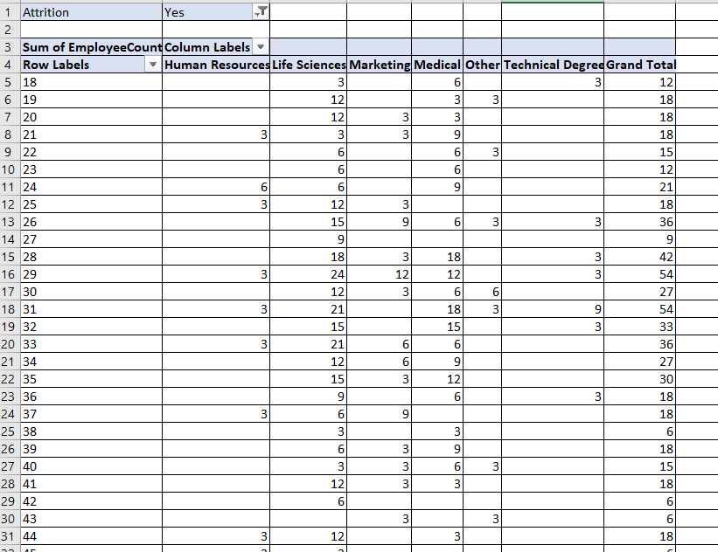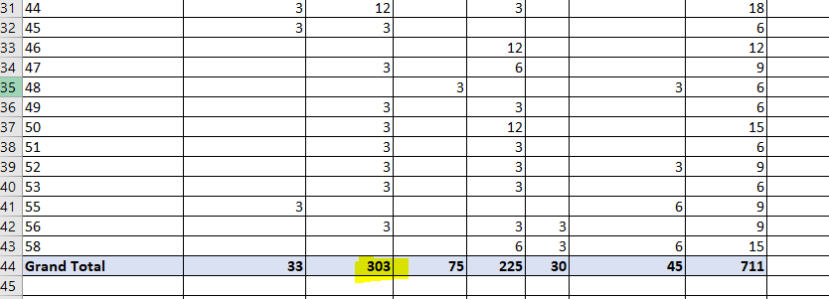

6. Attrition is high for Employees who have spent less time in company and who haven’t had given any promotion

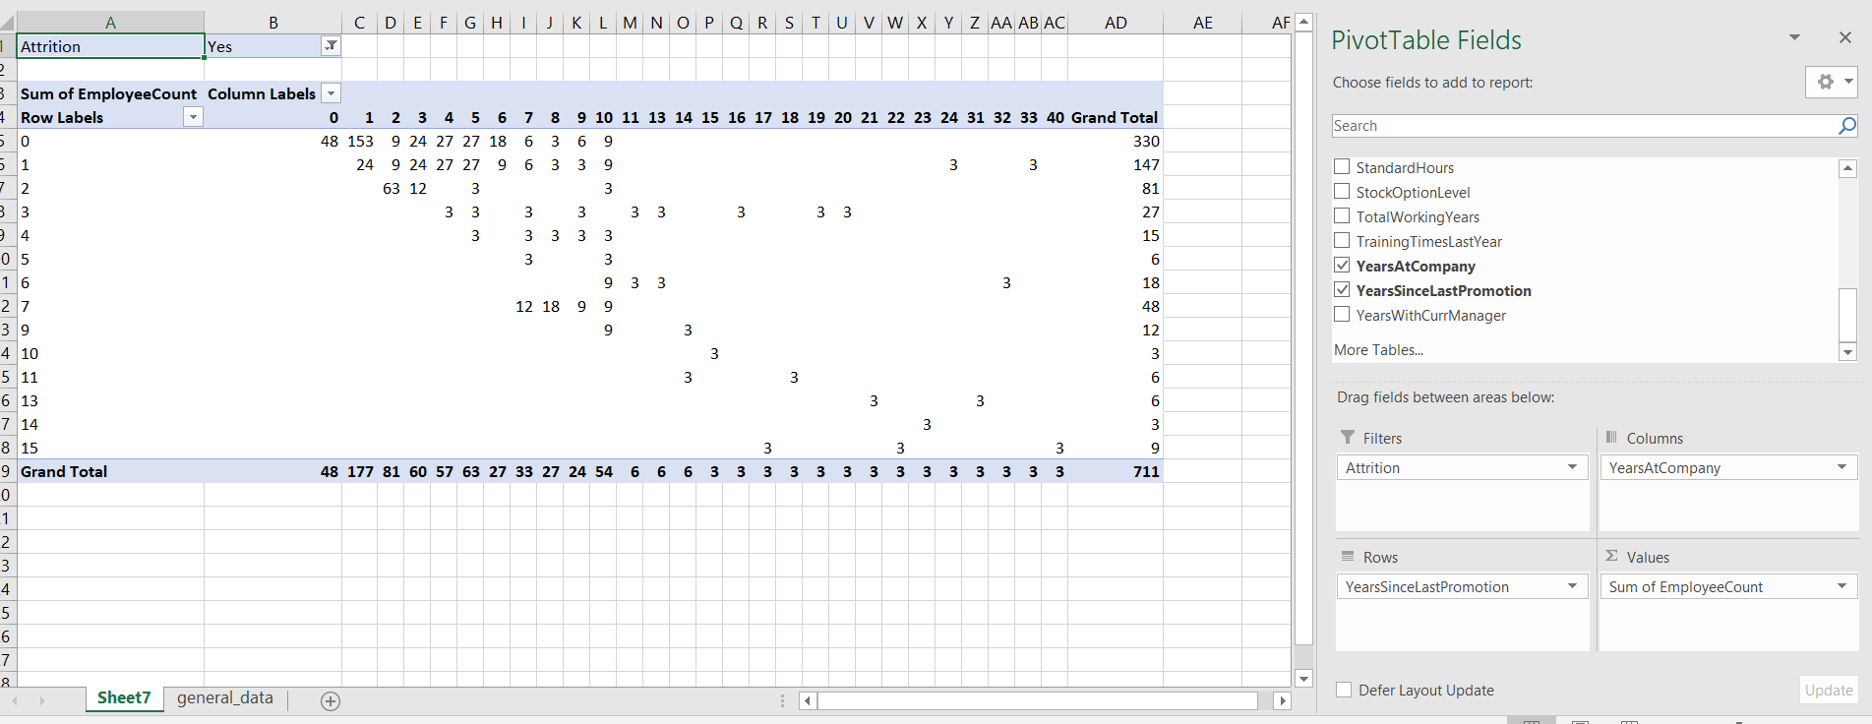

7. Research & Development Team Employees are taking home maximum Salary provided in the company.

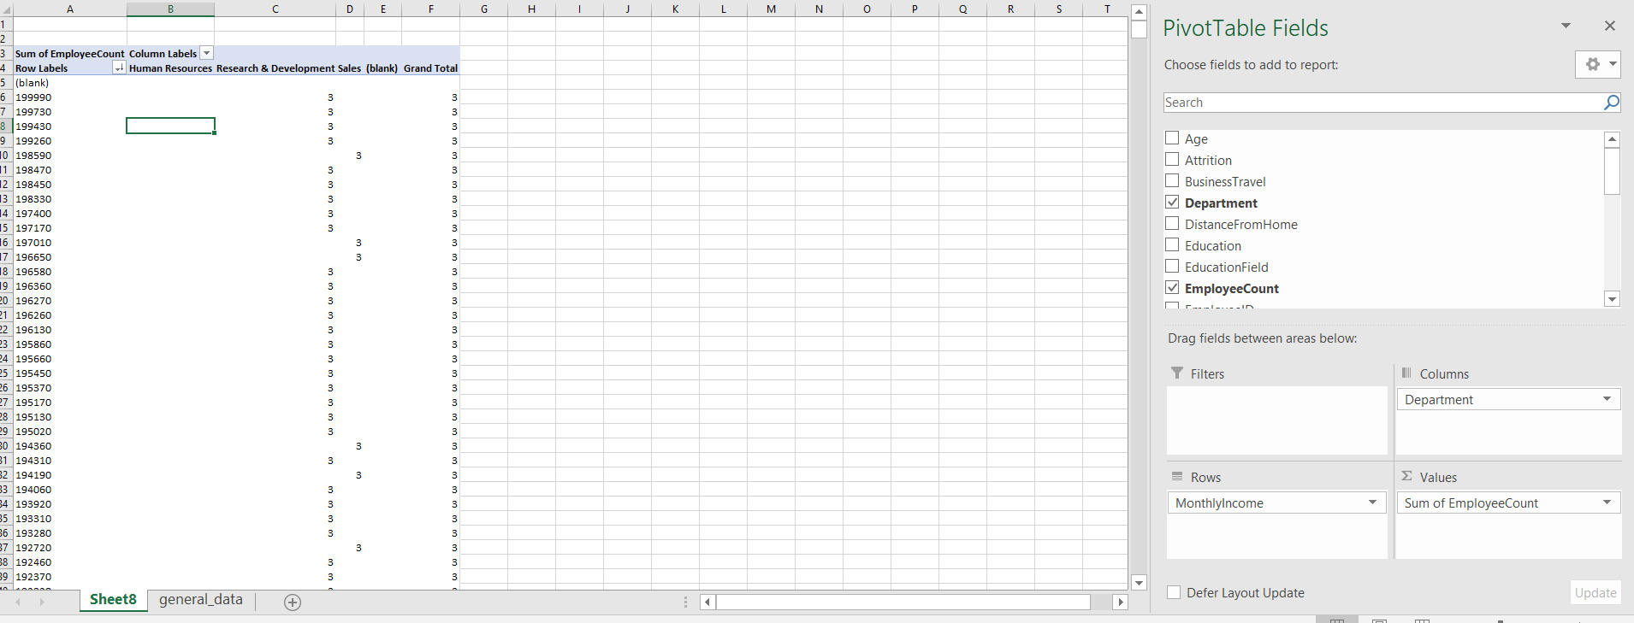

8.Male Employees are given the max opportunity to Travel Frequently in the company.

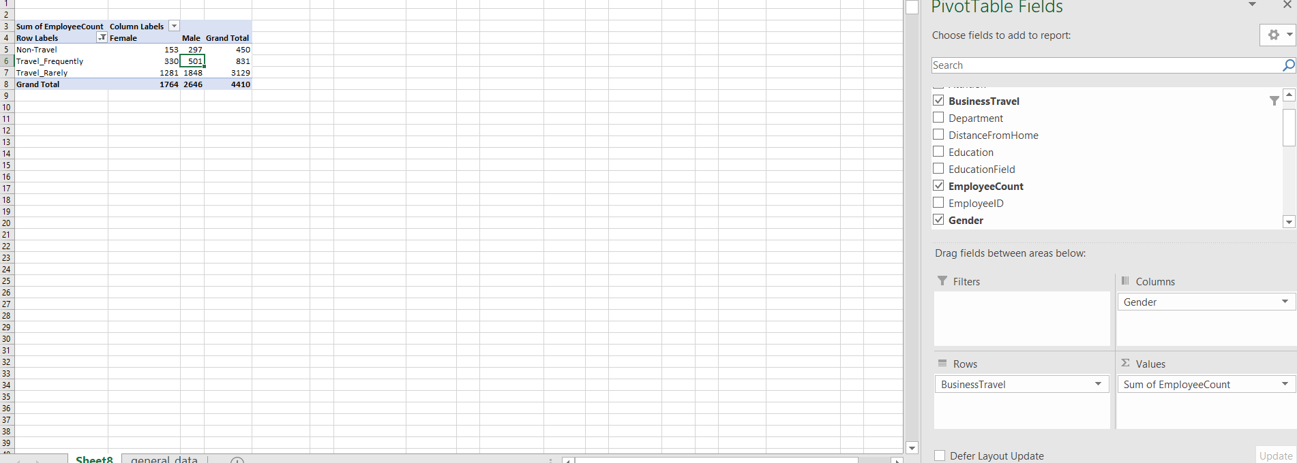

9.Maximum Employees in the company are in the range of 5-10 yrs experience.

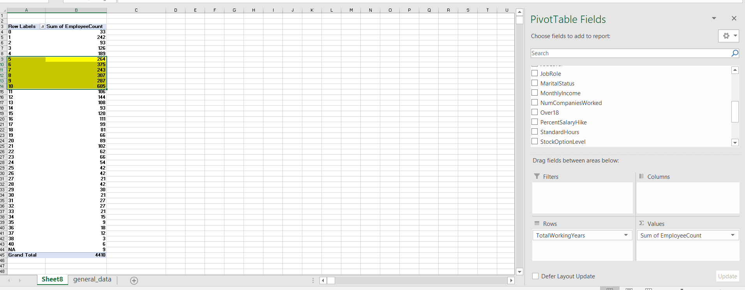

10. Attrition is minimal in the range of 5-10 yr experience in the company

